https://github.com/Clans/FloatingActionButton

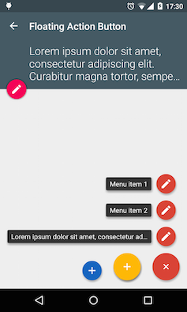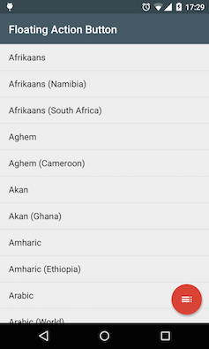

https://github.com/zcweng/ToggleButton



https://github.com/weddingparty/AndroidFloatLabel



https://github.com/rengwuxian/MaterialEditText

